**Beauty Section**

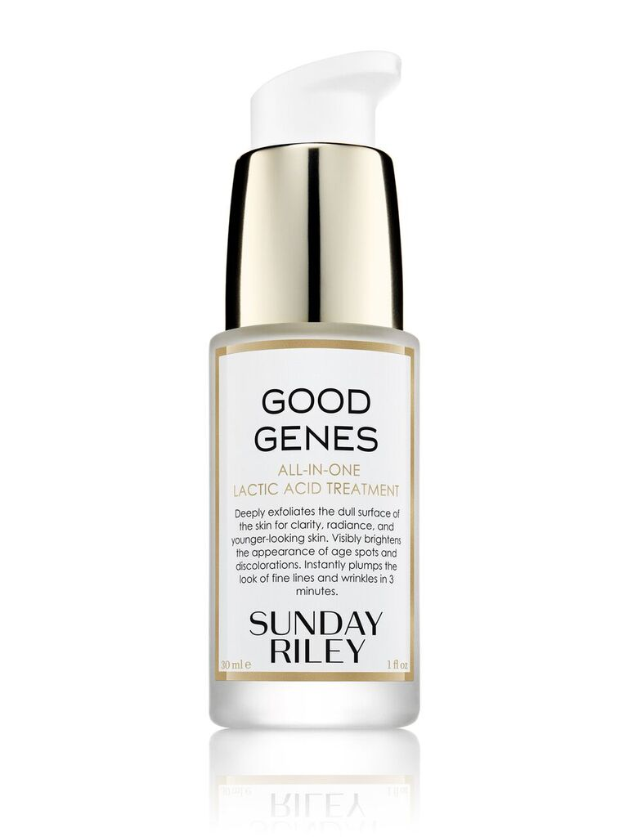

*Sunday Riley*

* Does your skin look like it needs some TLC? Sunday Riley’s Good Genes All-In-One Lactic Acid Treatment ($148) contains a high potency of lactic acid, an alpha hydroxyl acid (AHA), clinically proven to help reduce signs of aging, discolouration, oiliness, acne, and pore size. Including ‘now and later’ benefits, the treatment has instant results leaving your skin looking rejuvenated as well as long-term payoff. Shop the full Sunday Riley range in store at Sephora or at sephora.sg

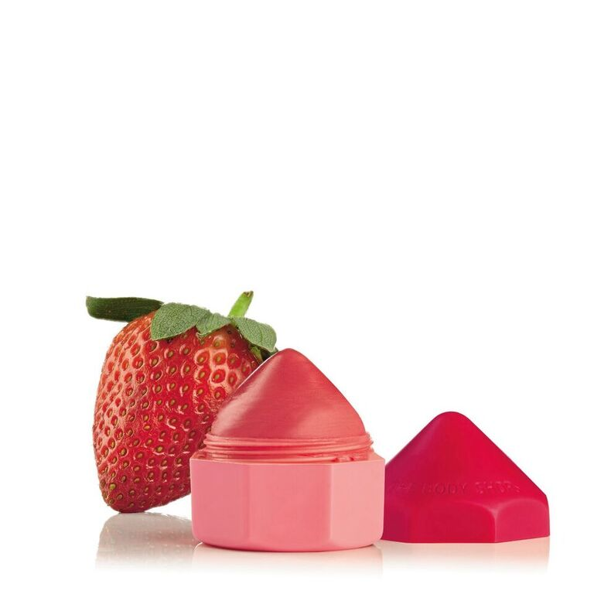

*The Body Shop*

* Give your lips a much needed moisture boost with The Body Shop’s new Lip Juicers ($14)! Made from Ghanaian Community Trade organic shea butter, organic olive oil, and marula oil, these naturally scented lip balms are not only extremely cute but are also 100% vegan! Their small sizes are perfect for fitting into any purse, keeping your lips moisturised everywhere you go. These crayon-like lip balms can be purchased at any Body Shop outlet or online at thebodyshop.com/en-sg/

*Pony Effect*

* 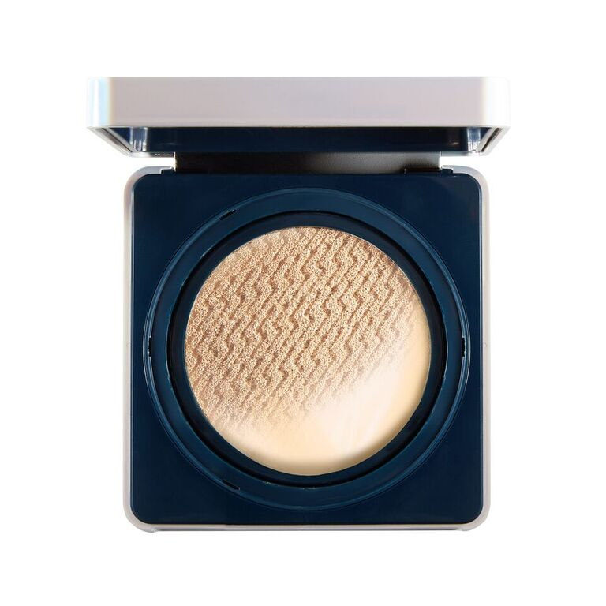Pony Effect’s Defense Longwear Cushion ($65.90) is the perfect foundation for battling Singapore’s heat and humidity. Coined as a super long-lasting cushion foundation, the product skins into the skin quickly and is then locked with the help of a makeup-holding system staying in place despite sweat. The cushion also allows for buildable coverage, giving users the option for a natural or full-coverage look. This product along with other Pony Effect products will be launching at selected Watsons stores.

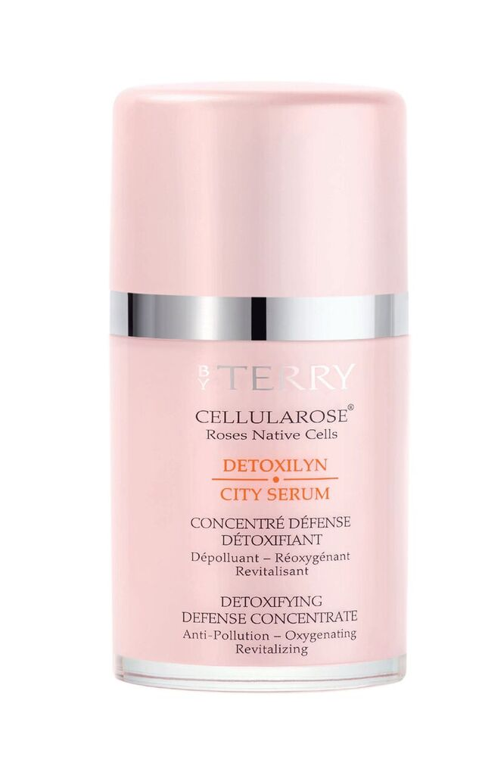*By Terry*

* By Terry’s new Detoxilyn City Serum ($205) is a multi-defense shield as it is not only anti-pollution, but also brightens, soothes, and evens out uneven skin tones. Everyday use of the serum not only protects the skin from pollution but also repairs the damage that was done previously, leaving a smooth, glowing complexion. The high concentration of ingredients in the serum penetrates the skin deeper, giving the skin the full benefits as well as allowing other products to perform better. The By Terry Detoxilyn range is available for purchase at escentials TANGS at Tang Plaza, escentials Paragon, and escentials.com from July 2018.